**CAMERA CAPTURE BASED ON AFORGE**

**PENGOLAHAN CITRA**

**MK401**



**Disusun oleh :**

**Ricky Silitonga (4211901034)**

**PROGRAM STUDI TEKNIK MEKATRONIKA**

**JURUSAN TEKNIK ELEKTRO**

**POLITEKNIK NEGERI BATAM**

**2021**

**Introduction To Camera Capture Based On Aforge**

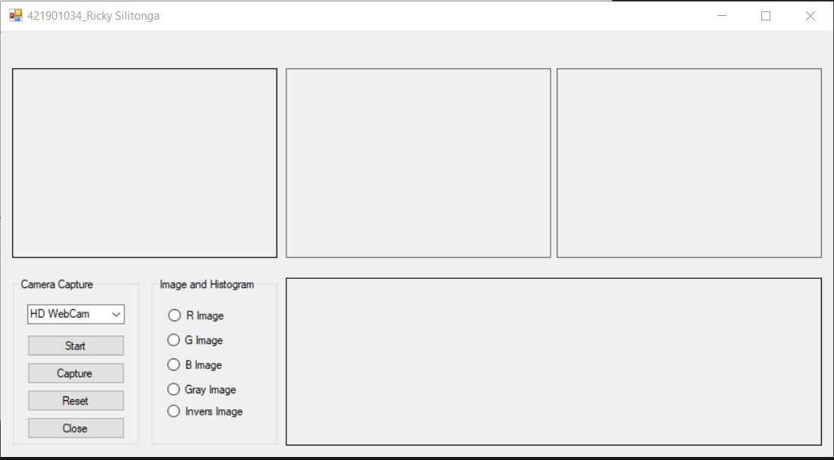

Gambar 1. Tampilan Awal

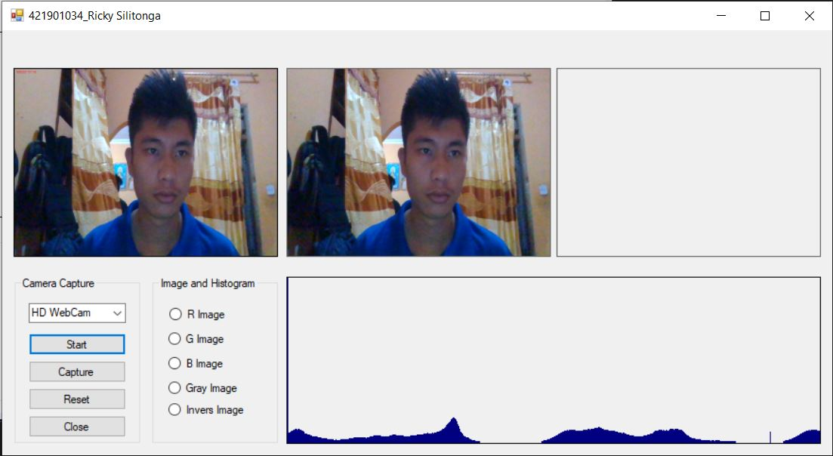

Gambar 2. Start Webcam

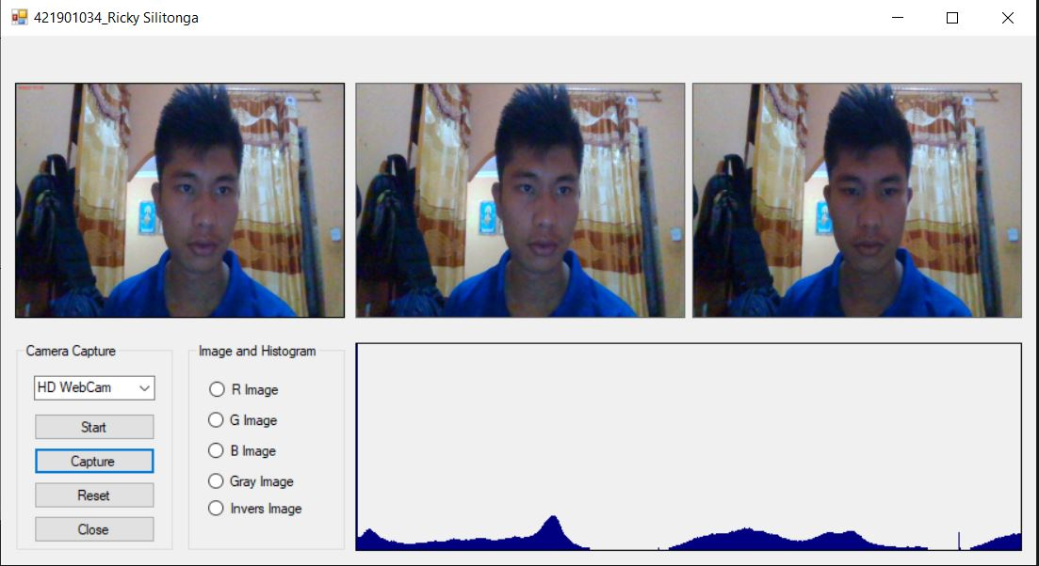

Gambar 3. Tombol Capture di klik

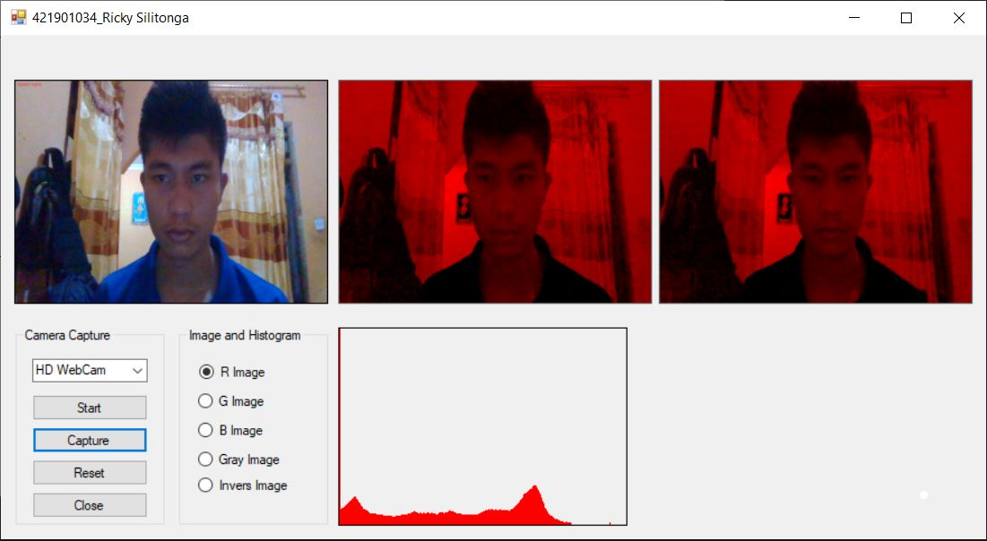

Gambar 4. R Image + Capture

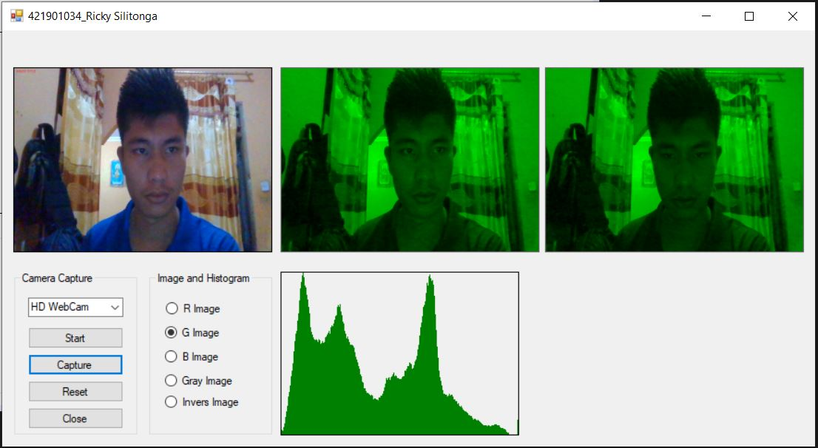

Gambar 5. G Image + Capture

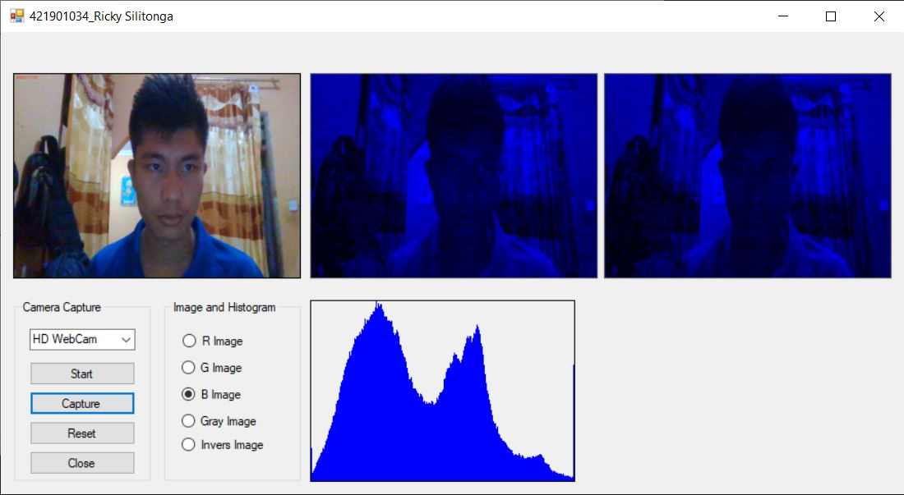

Gambar 6. B Image + Capture

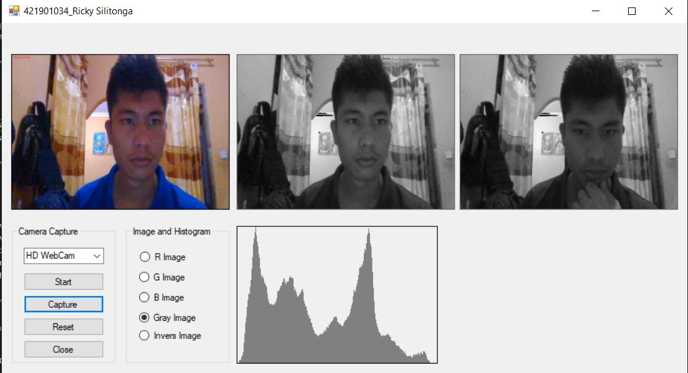

Gambar 7. Gray Image + Capture

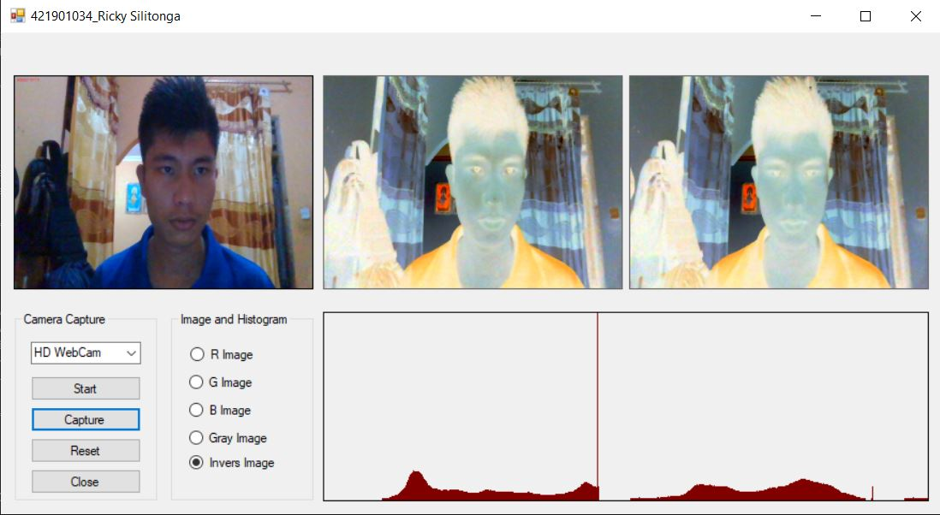

Gambar 8. Invers Image + Capture

Source Code

